**Content**

1. **Introduction------------------------------------------------------------ 3**
2. **Project Title------------------------------------------------------------ 3**
3. **Objective---------------------------------------------------------------- 3**
4. **Justification------------------------------------------------------------ 3**
5. **System Overview------------------------------------------------------ 4**
6. **Stakeholder Analysis------------------------------------------------- 5-9**
7. **Feasibility Study------------------------------------------------------ 10-11**
8. **System Component--------------------------------------------------- 12**
9. **Process Model--------------------------------------------------------- 13**
10. **Budget------------------------------------------------------------------ 13**
11. **Effort Estimation----------------------------------------------------- 14-16**
12. **Activity Diagram----------------------------------------------------- 17-18**
13. **Risk Analysis---------------------------------------------------------- 19-20**
14. **Conclusion------------------------------------------------------------- 21**

**1.0 Introduction:** The purpose of this document is to develop a Job for Mosque which will be able to recruit any Imam, Muazzin, and Khadim for the mosque. This document will give a complete idea of how this project will be successfully completed for the clients and the developer team. In Bangladesh majority of people are Muslim and every mosque still recruits their Imam, Muazzin, and Khadim manually and this process is also too time-consuming. By using our system any Imam, Muazzin, and Khadim find their job and a recruiter finds their expected Imam, Muazzin, or Khadim very quickly without facing any hassle. Moreover, the main objective of this document is to reduce the hassle and time-consuming of recruitment (Imam, Muazzin, and Khadim) for the mosque and as well as for the people who find the job as Imam, Muazzin, and Khadim. The project manager is the head of this document.

The recruiter and applicant are the main audiences of this document. The recruiter will give recruitment posts for the mosque through the application. And the applicant do apply upon that recruitment post.

**2.0 Project Title:** Job for Mosque

**3.0 Objectives:** In this document, the specific goal here is to develop a web-based application. which includes methods like registration of recruiter and applicant, login of recruiter, applicant, and admin, recruiter do post and communicate, applicant do apply and communicate etc.

And the overall objective of this document is to create a system that will reduce time and hassle to search the people who will work for the mosque. And lastly, this sector still woks manually. So, converting this sector from manually to online platform.

**4.0 Justification:** The purpose of this system-

* To reduce the hassle and time-consuming.
* To create an easy environment for recruitment.
* To create an easy environment for job finders.
* Converting this sector to the online platform in the proper way.
* Will get more people and job options for the recruiter and applicant.

With this system, the recruiter and applicant will be more benefited. Because a recruiter can get many applicants within a short time and can easily choose an applicant by judging. On the other hand, an applicant also gets many recruitment offers within a short time and can easily apply.

**5.0 Systems Overview:** When a user use this application they have to sign up and there will be two option. One is applicant and another is recruitment. In applicant option candidate can make their own profile and apply for imam or muazzin. In our software there will have database. In this database all the information will save of the candidate who want to be a imam or muazzin. There will be a notification bell system which shows which mosque need imam or mosque to the candidate. Candidate can apply those recruitment post via notification bell.

There will another option name recruitment which allow user that post a recruitment for imam or muazzin. When user post a recruitment of imam or muazzin of that post candidate will response his post and user can show all the information of candidate which candidate upload on his profile. If user choose a candidate they can also communicate with the candidate. There will be another option name interview, which allow the user can take a interview with the candidate via video and audio.

And lastly, Admin will monitor overall the system.

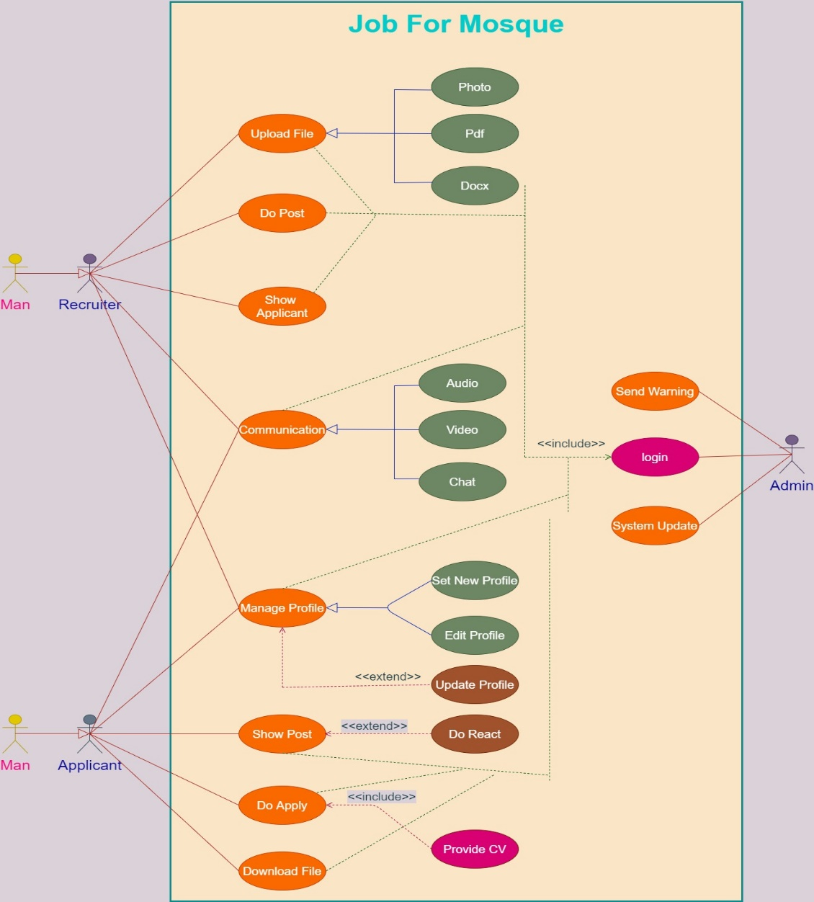

**6.0 Stakeholder Analysis:**

**Internal Stakeholder:**

|  |  |  |
| --- | --- | --- |
| **Name** | **Position** | **Role** |
| Md. Taufiqul Islam | Board of the Director | Maximizing the profit the business makes and achieving a return for investors. |
| Md. Shahed Islam | Project Manager | Planning, procurement and execution of a project |
| Md. Tanvir Islam | Requirement Engineer | Collaboration with stakeholders, defines, documents, validates and manages requirements. |
| Md. Abir Islam | System Analyst | Manages and enhances computer and software systems directly for organizations or their clients. |
| Md. Rabiul Islam | Resource Manager | Helps project managers with planning and allocating resources for a project |
| Md. Takiul Islam | Software Architect | Design the system |
| Md. Fuad Hassan | Software Test Engineer | Discover bugs in software before the release of an app or product. Write a test plan based on the requirements and functionality of the system. |
| Md. Atik Islam | Senior Tester (Manual) | Analyze the requirement document given by the client and execute the test cases written by junior testers. |
| Md. Shohidul Islam  Md. Rahim Islam  Md. Fiaz Karim  Md. Faraz Hossain | Junior Tester | Wrote the test cases. |
| Md. Sarfaraz Hassan | Senior Tester (Automated) | Develop and maintain automation test suits. |
| Md. Rabiul Islam  Md. Tanjimul Haque  Md. Kabir Hassan | Front-end Developer | Designs each aspect of a website that users can see and with which they interact. |
| Md. Tammad Chowdhury  Md. Shoummo Akter  Md. Rabiul Reza | Back-end Developer | Responsible for creating the underlying code of a user interface site, instead of the aesthetics and visual functionality of a site. |
| Md. Muminul Islam | Database Architect | Designing the databases in an organization. Evaluates the business requirements and drafts the data models. |
| Md. Muhaiminul Islam | Maintenance Engineer | Responsible for installing, monitoring, and maintaining and on-premises equipment. Will support after deployment of the product to the customer |

**External Stakeholder:**

|  |  |
| --- | --- |
| **Name** | **Role** |
| Admin  Recruiter  Applicant | End User |
| Md. Sharif Islam  Md. Araf Islam  Md. Robi Mondol | Suppliers |
| Md. Alamin Hossain  Md. Al Jubayer  Md. Ashraf Uddin | Vendors |
| Md. Shofique Islam  Md. Shamim Osman | Government Regulators |
| Md. Misu Rahman  Md. Shuvro Talukdar  DGH Company | Investor |
| ABS Company  LKG Company | Partner |
| BCS Hospital  Computer Plaza | Local Company |
| Brack Bank  Islami Bank  Dutch Bangla Bank | Creditors |

**Stakeholder Prioritization For Internal Stakeholders:**

|  |  |  |  |  |
| --- | --- | --- | --- | --- |
| **#** | **Short Form** | **Stakeholder** | **Impact of Charge(Interest)** | **Level of Influence(Power)** |
| 1 | BOD | Board of the Director | 6 | 9 |
| 2 | PM | Project Manager | 9 | 8 |
| 3 | RE | Requirement Engineer | 6 | 7 |
| 4 | SA | System Analyst | 5 | 1 |
| 5 | RM | Resource Manager | 3 | 4 |
| 6 | SA | Software Architect | 4 | 1 |
| 7 | STE | Software Test Engineer | 5 | 6 |
| 8 | ST | Senior Tester (Manual) | 5 | 5 |
| 9 | JT | Junior Tester | 3 | 1 |
| 10 | ST | Senior Tester (Automated) | 4 | 5 |
| 11 | FD | Front-end Developer | 7 | 6 |
| 12 | BD | Back-end Developer | 5 | 6 |
| 13 | DA | Database Architect | 6 | 7 |
| 14 | ME | Maintenance Engineer | 5 | 7 |

High Power, High Interest

**Stakeholder Prioritization For External Stakeholders:**

|  |  |  |  |  |
| --- | --- | --- | --- | --- |
| **#** | **Short Form** | **Stakeholder** | **Impact of Charge(Interest)** | **Level of Influence(Power)** |
| 1 | EU | End User | 9 | 0 |
| 2 | S | Suppliers | 7 | 7 |
| 3 | V | Vendors | 6 | 5 |
| 4 | GR | Government Regulators | 6 | 6 |
| 5 | I | Investor | 8 | 7 |
| 6 | P | Partner | 9 | 9 |
| 7 | LC | Local Company | 6 | 3 |
| 8 | C | Creditors | 5 | 4 |

Low Power, High Interest

Low Power, Low Interest

High Power, High Interest

High Power, Low Interest

**7.0 Feasibility Study:**

**Technical Feasibility:**

The main objective of the technical feasibility of this system is to determine whether the project is technically feasible, and to produce the software profitably. It inspects whether software can be built at all with available tools and experts.

Our Project is a complete web-based project. The main technologies and tools that are used in this project are: HTML, CSS, MySQL, JavaScript, React.js (For front-end), React Bootstrap, Laravel (For back-end), Context API, Firebase. Each of the technology are freely available and the technical skills required are manageable. Time limitations of the project development and the ease of implementing using these technologies are synchronized.

In this system, all system analysts, users, programmers, testers, and management have a good grasp of what kinds of tasks must be accomplished for software development.

Initially, the website of this project will be hosted in a free web hosting space and after that for later implementations, it will be hosted in a paid web hosting space with sufficient bandwidth. The bandwidth required in this application is very low since it doesn’t incorporate any multimedia aspect.

From these, it’s clear that the project’s Job for Mosque system is technically feasible.

**Financial Feasibility:**

As our project is a web-based project for this reason it will have an associated hosting cost. The bandwidth required in this project is very low. There will have an associated cost for bug fixes and maintaining tasks cost. There will also cost for testing (manual and automated) the whole system. All required cost for final development like software resource required, design and development cost, and operational cost is not quite expensive. Labor costs like Managers, programmer, testers, and QA testers must include all the professionals involved in the development time. our project may necessitate infrastructure changes, such as an upgraded server setup or expanded cloud storage capacity.

We will try to establish a minimal-viable product requirements with the stakeholders, explaining the necessity of limiting the scope and the possibility of adding elements subsequently. These investments are often considerable and may extend beyond the initial launch of our software application. We will keep the costs and timelines of this project in check, we will budget around the must-haves to get to launch.

From these, it’s clear that the project’s Job for Mosque system is financially feasible.

**Resource Feasibility:**

All resources that are required to establish this project are available like

1. Programming tools (Visual Studio, Composer, node js)
2. Basic tools (Microsoft 360, Drawio, Browser, Notepad)
3. Programming Device (Laptop or PC)
4. Testing tools (Selenium, Eclipse IDE)
5. Bandwidth, Working Environment (Office)
6. Free hosting space
7. Man power (Programmers (6), Testers (8)).

So, it’s clearly seen that the project’s Job for Mosque system has resource feasibility.

**Schedule Feasibility:**

Timelines/deadlines of the project schedule is analyzed for the proposed project at the initial stage of this project development. We schedule a Timeline that includes how many times teams will need to complete the final project which has a great impact on the project completed time.

So, it’s clearly seen that the project’s Job for Mosque system has Schedule feasibility.

**Operational Feasibility:**

For reducing the cost we will hire an all-rounder programmer. All-rounder programmer means a programmer who can do system design, create diagrams, and code. We can use free software or less price software. We will hire one or two expert testers. That expert senior testers can train other juniors less expert tester.

There will be a maintenance team. This maintenance team will support after deployment of the product to the customer for at least ten to fifteen years.

So, it’s clearly seen that the project’s Job for Mosque system has Operational feasibility.

**8.0 Systems Components:**

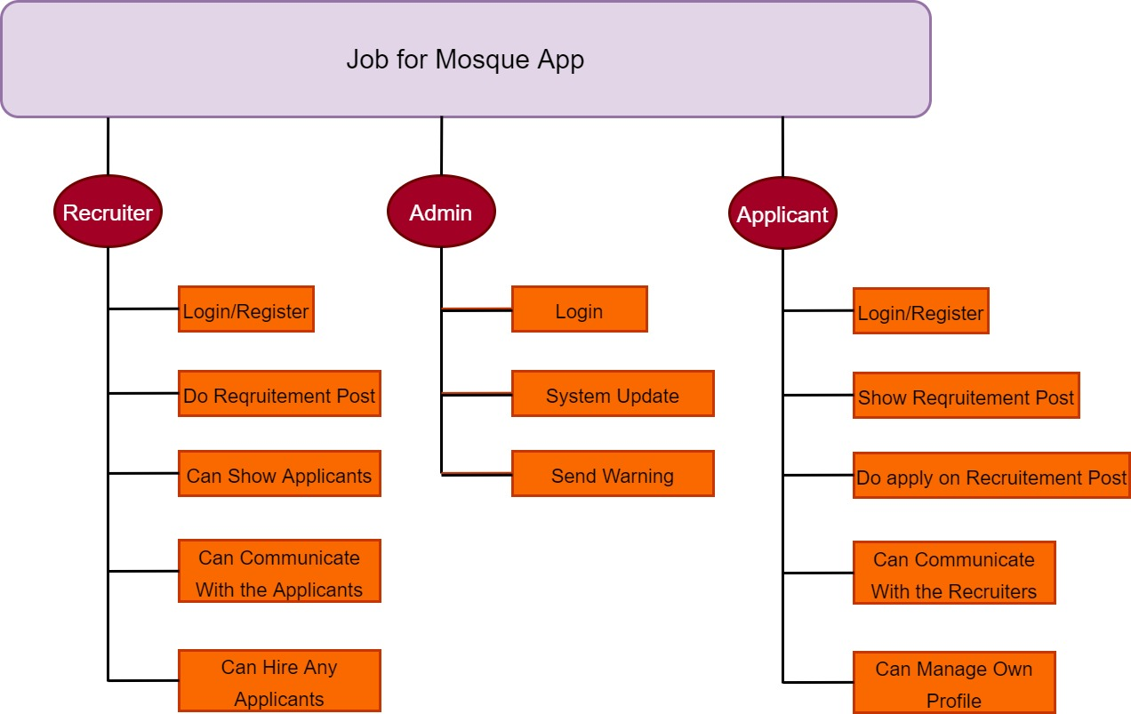

**9.0 Process Model:**

For our project, we will choose the saw tooth process model. Because-

1) Our project is linear and sequential.

2) Our project requirements are well understood.

3) We don’t need to deliver the product to the customer very early.

4} Our project has a testing phase.

5) Our project has client interaction. This means there will have some CR.

**10.0 Budgets:**

|  |  |
| --- | --- |
| **Activity** | **Amount (TK)** |
| Requirement Cost | 43680 |
| Planning Cost | 85120 |
| System Analysis & Design Cost | 73920 |
| Equipment Cost | 12000 |
| Utility Cost | 17000 |
| Development Cost | 125440 |
| Testing Cost | 151200 |
| Training Cost | 20000 |
| Market Promotion Cost | 30000 |
| Website Hosting Cost | 50000 |
| Product Release Cost | 44800 |
| Maintenance Cost | 10000 |
| Total= | 6,63,160/= |

**11.0 Effort Estimation:**

For the effort estimation, we have used the bottom-up approach.

**Work Break-Down Structure**

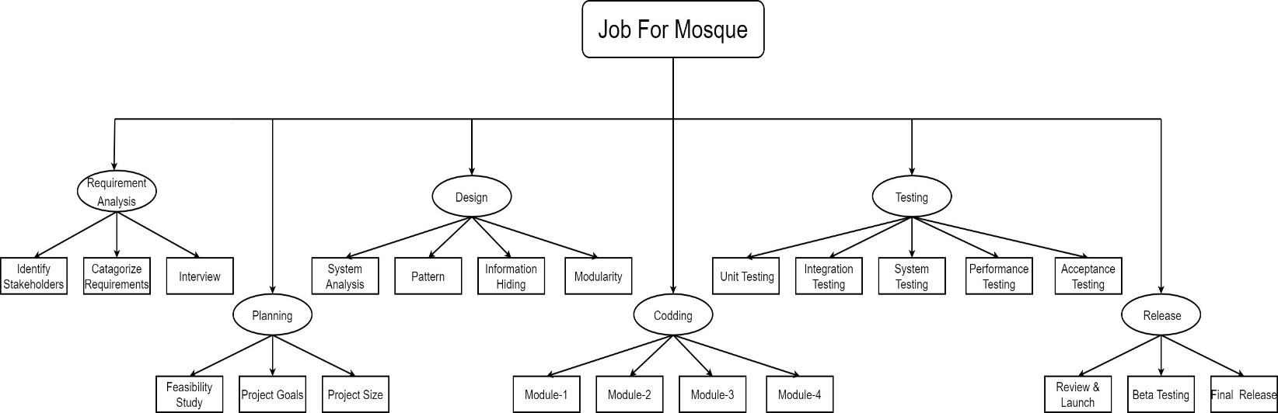

|  |  |  |  |  |
| --- | --- | --- | --- | --- |
| **Activity** | **Duration (Day)** | **Hour (Per Day Working Hour is 8)** | **Per Hour Salary (TK)** | **Total Amount (TK)** |
| Identify Stakeholders | 5 | 40 | 390 | 15600 |
| Categorize Requirements | 4 | 32 | 390 | 12480 |
| Interview | 5 | 40 | 390 | 15600 |
| Feasibility Study | 12 | 96 | 380 | 36480 |
| Project Goals | 6 | 48 | 380 | 18240 |
| Project Size | 10 | 80 | 380 | 30400 |
| System Analysis | 14 | 112 | 330 | 36960 |
| Pattern | 5 | 40 | 330 | 13200 |
| Information Hiding | 3 | 24 | 330 | 7920 |
| Modularity | 6 | 48 | 330 | 15840 |
| Module-1 | 14 | 112 | 280 | 31360 |
| Module-2 | 14 | 112 | 280 | 31360 |
| Module-3 | 14 | 112 | 280 | 31360 |
| Module-4 | 14 | 112 | 280 | 31360 |
| Unit Testing | 56 | 448 | 135 | 60480 |
| Integration Testing | 35 | 280 | 135 | 37800 |
| System Testing | 21 | 168 | 135 | 22680 |
| Performance Testing | 14 | 112 | 135 | 15120 |
| Acceptance Testing | 14 | 112 | 135 | 15120 |
| Review & Launch | 14 | 112 | 100 | 11200 |
| Beta Testing | 35 | 280 | 100 | 28000 |
| Final Release | 7 | 56 | 100 | 5600 |

For The Effort Estimation of Requirement Analysis:

= 15600+12480+15600

= 43680 TK

For The Effort Estimation of Planning:

= 36480+18240+30400

= 85120 TK

For The Effort Estimation of Designing:

= 36960+13200+7920+15840

= 73920 TK

For The Effort Estimation of Coding:

= 31360+31360+31360+31360

= 125440 TK

For The Effort Estimation of Testing:

= 60480+37800+22680+15120+15120

= 151200 TK

For The Effort Estimation of Release:

= 11200+28000+5600

= 44800 TK

Total Effort Estimation:

= 43680+85120+73920+125440+151200+44800

= 5,24,160 TK

**12.0 Activity Diagram:**

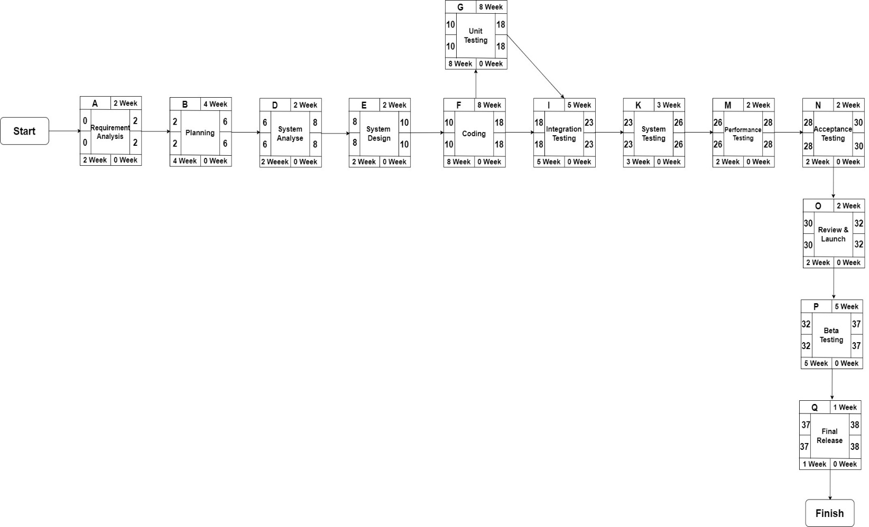

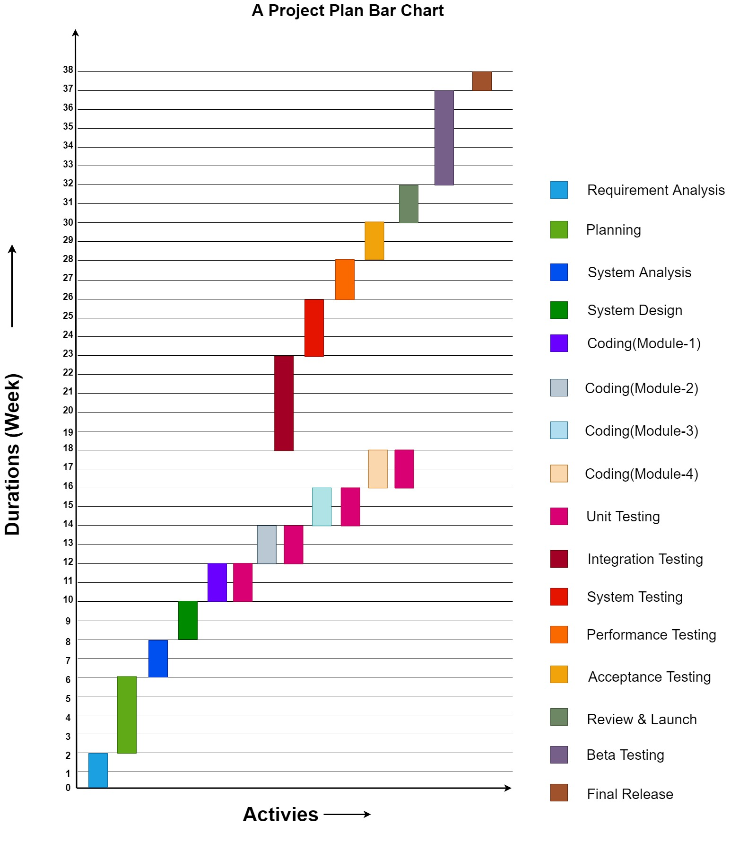

**13.0 Risk Analysis:**

|  |  |  |  |  |
| --- | --- | --- | --- | --- |
| **Ref.** | **Hazard** | **Likelihood** | **Impact** | **Risk Exposer** |
| R1 | Employees could be sick in the office. | 6 | 3 | 18 |
| R2 | Could be data deletion, computer hardware failure, or network failure. | 2 | 7 | 14 |
| R3 | Defects in design. | 4 | 8 | 32 |
| R4 | Failure to meet the user requirement. | 2 | 9 | 18 |
| R5 | Coding of any part takes time much  than expected. | 5 | 6 | 30 |
| R6 | Possible budget underrun. | 4 | 7 | 28 |
| R7 | Defects in planning. | 4 | 9 | 36 |
| R8 | Real-time performance problem. | 5 | 6 | 30 |
| R9 | Developing the wrong software functions. | 5 | 2 | 10 |
| R10 | Could be a lack of power supply, or components damage/failure (like AC, light, etc.). | 8 | 1 | 8 |
| R11 | Could be an unexpected holiday (like a strike, natural disaster, office maintenance, etc.). | 7 | 5 | 35 |
| R12 | The office may catch fire. | 5 | 6 | 30 |
| R13 | Delayed Testing Due To new Issues. | 6 | 8 | 48 |
| R14 | The project is too complex to implement. | 2 | 7 | 14 |
| R15 | Time is not estimated properly for the project. | 2 | 7 | 14 |
| R16 | Staff, skills, and systems are not tracked properly | 4 | 6 | 24 |
| R17 | Poor risk management. | 6 | 8 | 48 |
| R18 | Changing project scopes. | 4 | 6 | 24 |
| R19 | Stakeholder issues | 7 | 4 | 28 |
| R20 | Project team members leaving | 9 | 6 | 54 |

**Risk Prioritization:**

|  |  |
| --- | --- |
| **Risk Ref.** | **Probability Level** |
| R1 | Moderate |
| R2 | Moderate |
| R3 | High |
| R4 | Moderate |
| R5 | Significant |
| R6 | Significant |
| R7 | High |
| R8 | Significant |
| R9 | Moderate |
| R10 | Low |
| R11 | High |
| R12 | Significant |
| R13 | High |
| R14 | Moderate |
| R15 | Moderate |
| R16 | Significant |
| R17 | High |
| R18 | Significant |
| R19 | Significant |
| R20 | High |

**High= >30**

**Significant= 20 to 29**

**Moderate= 10 to 19**

**Low= Within 10**

**14.0 Conclusion:**

Our Job for Mosque app will allow people in today’s mobile and digitally advanced society to participate in the democratic process over the internet. A mosque is a place for worship. In Bangladesh majority of people are Muslim for which reason we can find mosques everywhere in different areas. It is known that the mosque is maintained by Imam, Muezzin, and khadim. Our system will help to requite them in the mosque which will be useful for everybody. Through this software, the imam, muazzin, and khadim can apply for other mosques. Besides, there will also be a donation system for the mosque. As our software will be a one-stop for people who are seeking jobs to be a future Imam or Muezzin, a lot more vacant positions will be available for them to choose. For example, one can find many vacant positions for his desired jobs in the area he is interested in. On the other hand, seeking a job offline is difficult as one may need to go to different mosques to collect information. Offline recruitments take time and are a lengthy procedure. Unlike this type of recruitment, our software system will take the least amount of time to do the whole recruitment. Usually, offline recruitment requires applicants to do some paperwork and they might need to go places to register. On the other hand, our system won’t take this much effort to find a job for aspiring Imams or Muezzins. As this will be held online, the experience will be smoother and effortless.

**----------------------------------The End------------------------------------**